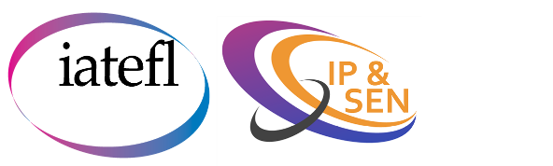
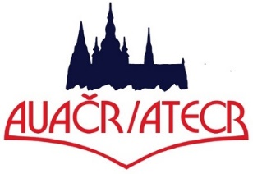
Call for Papers

We look forward to welcoming you to these events.
“No limits”
The IATEFL Inclusive Practices and SEN SIG (IP&SEN SIG) & the Association of Teachers of English of the Czech Republic (ATECR) invite proposals for contributions to an online event to be held on September 11th and 12th, 2020. The event will be hosted on the zoom platform.
We are looking for 45-minute sessions which will inspire English teachers to push themselves and their learners beyond their current limits. This could include (but is not restricted to) talks about:
- strategies for working inclusively (face-to-face or online)
- adapting materials and activities to the online environment
- the use of technology and assistive technology in English language teaching
- maintaining student and teacher well-being

To send your proposal, please complete the form below and return it to IPSENSIG@IATEFL.ORG or atecr@centrum.cz by Friday 31st July 2020
Name:
Email address:
Proposed title
(20 words max.):
Outline of session
(200 words max.):

